Q1

Write a C program using nested if-else to find the second largest number among three

integers entered by the user.

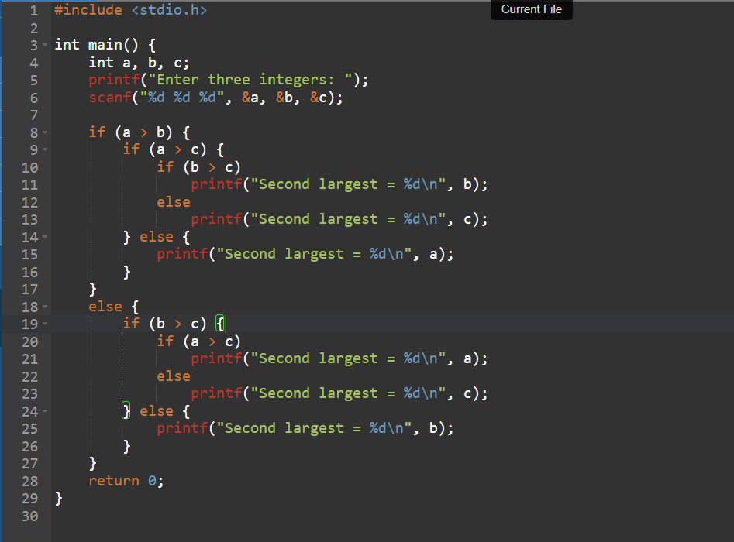

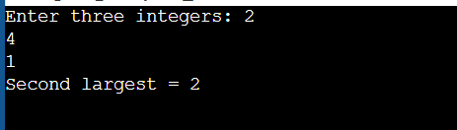

Q2

Write a C program using nested if-else to calculate the electricity bill for a user where

the cost is Rs. 5 per unit for the first 100 units, Rs. 7 per unit for the next 100 units, Rs.

10 per unit for the next 100 units, and Rs. 15 per unit for units above 300.

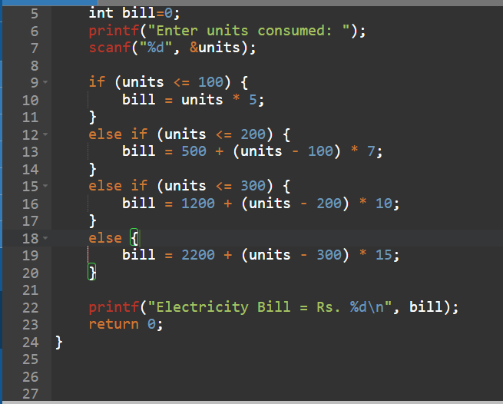

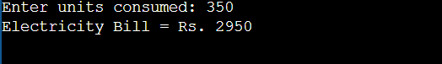

Q3

Write a C program using nested switch-case to create a Library Management System

where the user selects whether they want to manage books or magazines, and inside

each choice, they can either issue or return the item.

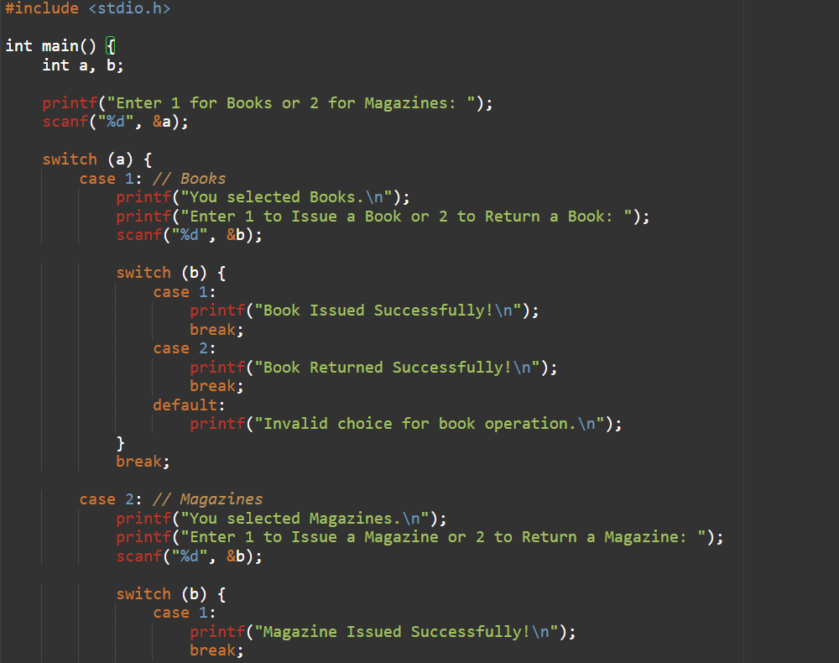

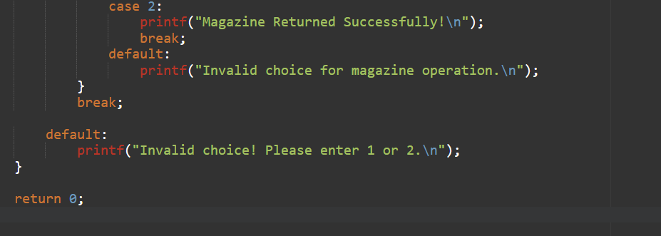

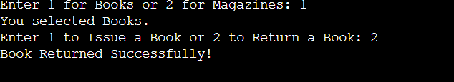



Q4

Write a C program using nested switch-case to simulate an Online Food Ordering

System where the user first selects a category (Fast Food or Drinks) and then chooses

a specific item to order.

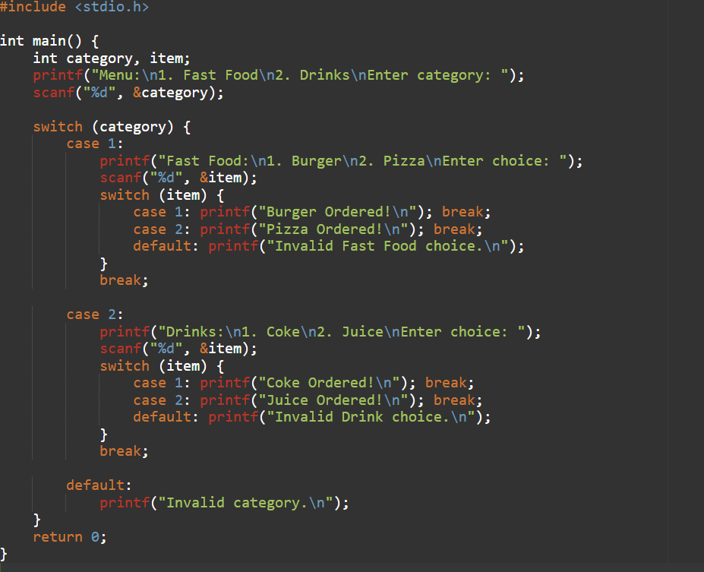

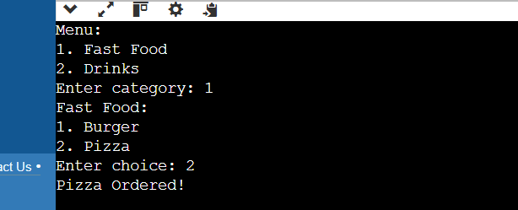

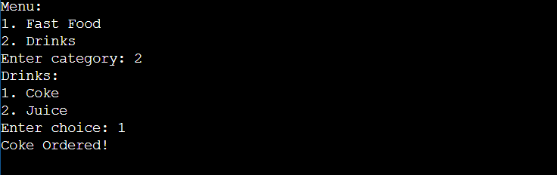

Q5

Write a C program using nested if-else and math.h to solve a quadratic equation ax² +

bx + c = 0 and print whether the roots are real and distinct, real and equal, or imaginary.

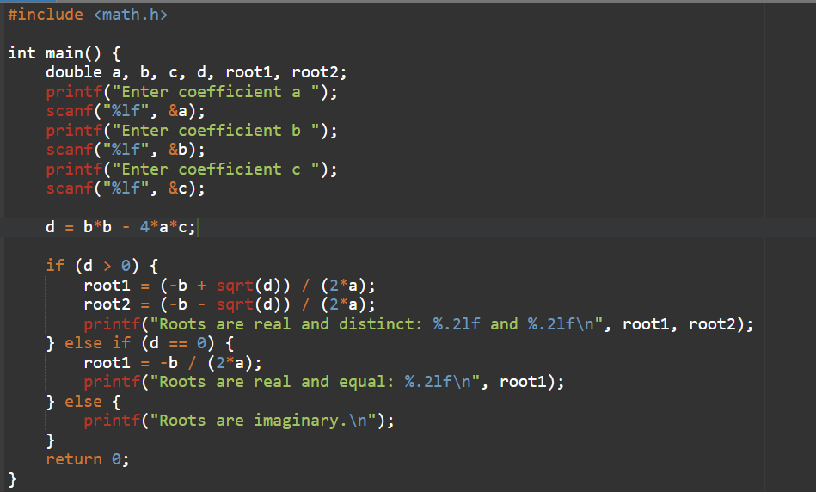

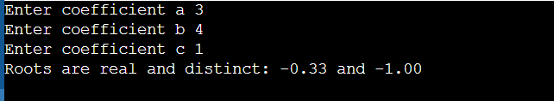

Q6

Write a C program using nested switch-case to create a Geometry Calculator where the

user first selects a shape (Circle, Rectangle, Triangle) and then chooses whether to

calculate its area or perimeter.

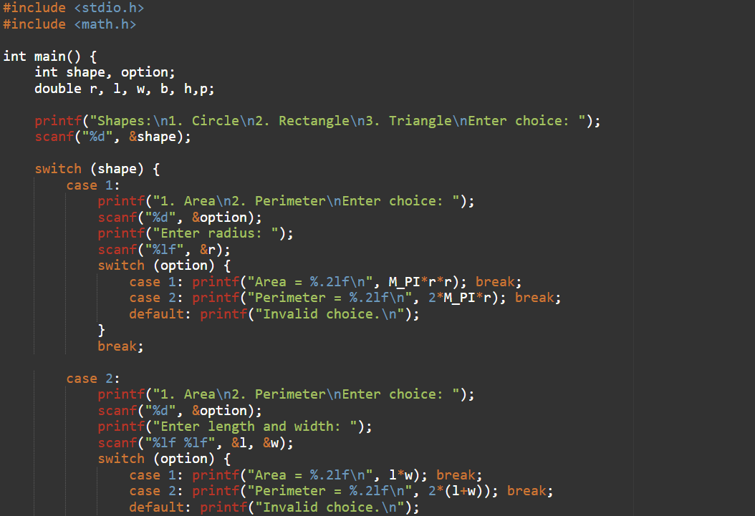

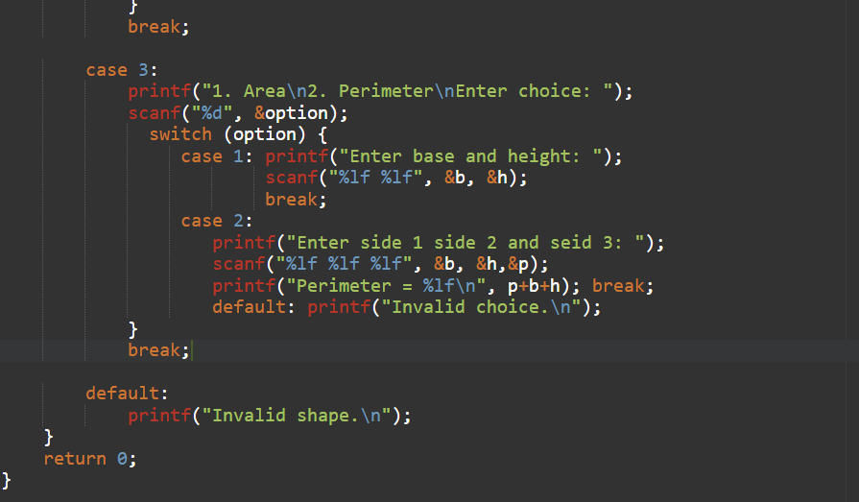

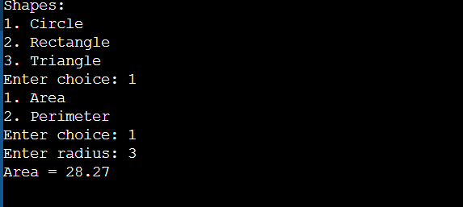

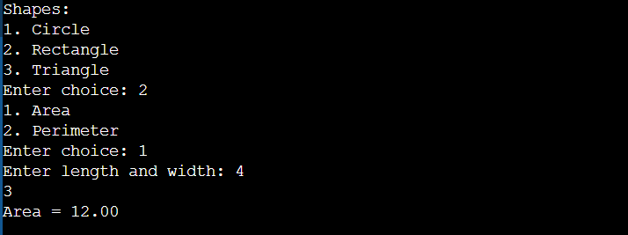

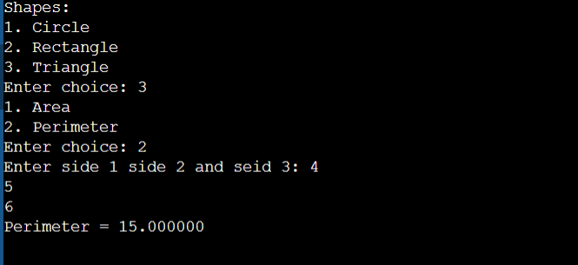

Q7

Write a C program using nested if-else to implement a Login System. The program

should ask the user to enter a username and password. If the username matches &quot;admin&quot;, check if the password matches &quot;1234&quot;. If both are correct, print &quot;Login

Successful&quot;. Otherwise, print appropriate error messages.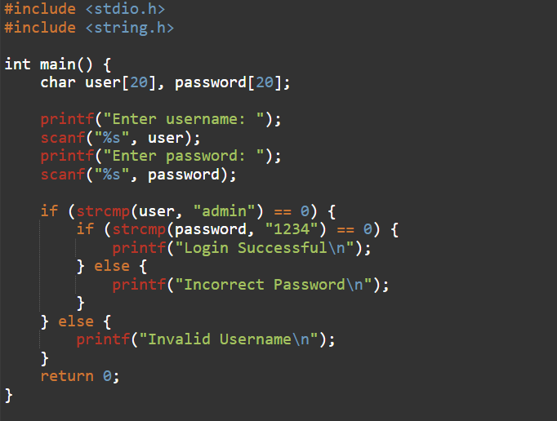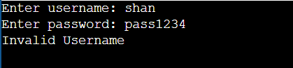

Q8

Write a C program using nested decision structures and math.h to calculate the monthly

installment (EMI) for a loan. The user enters loan amount, time (in years), and interest

type (1 for simple interest, 2 for compound interest). For compound interest, assume

interest is compounded annually. Print the EMI.

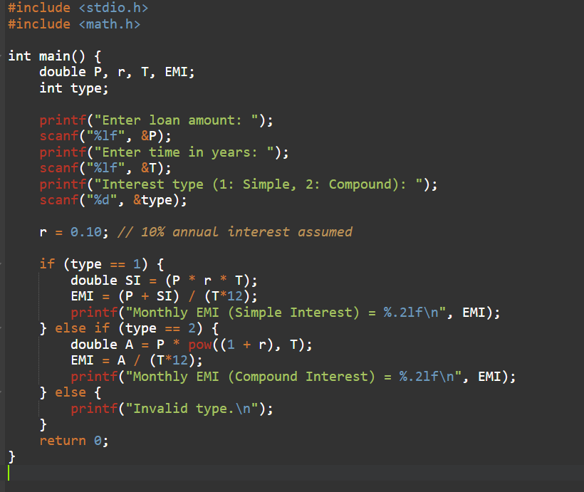

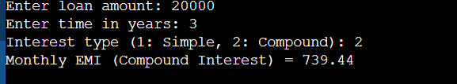

Q9

Write a C program using nested switch-case to design a University Course Registration

System. The user first selects a department (1. CS, 2. EE, 3. BBA). Based on the

department, display courses and let the user select one. Print the selected course

Name.

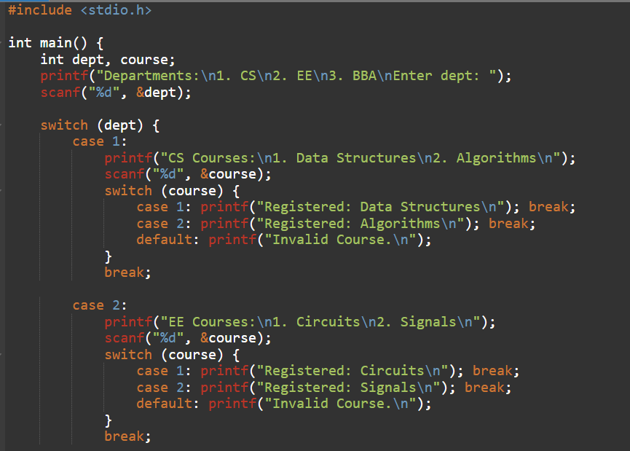

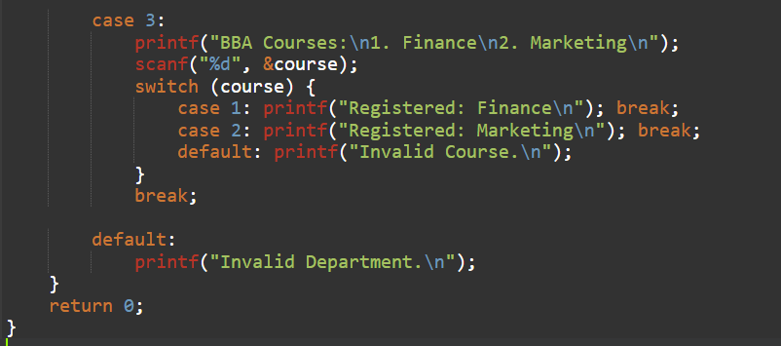

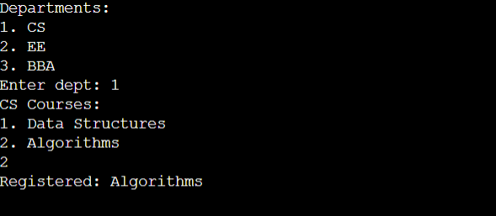

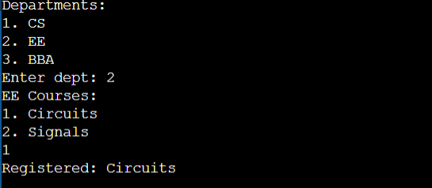

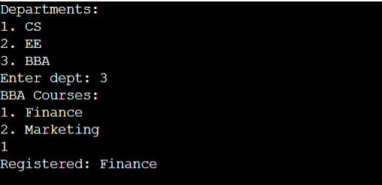

Q10

Write a C program where the user first enters age. Use if-else to check ticket price rules:

If age &lt; 12 → Child Ticket

If age between 12 and 60 → Adult Ticket

If age &gt; 60 → Senior Citizen Ticket

After category is decided, use a switch-case to allow selection of Movie (1. Action, 2.

Comedy, 3. Horror) and print the final ticket type + movie booked.

